# 7. 4 Congruent Triangles

CC BY Sherrie Thai

https://flic.kr/p/5ezxWj

*A Solidify Understanding Task*

We know that two triangles are congruent if all pairs of corresponding sides are congruent and all pairs of corresponding angles are congruent. We may wonder if knowing less information about the triangles would still guarantee they are congruent.

For example, we may wonder if knowing that two angles and the included side of one triangle are congruent to the corresponding two angles and the included side of another triangle—a set of criteria we will refer to as ASA—is enough to know that the two triangles are congruent. And, if we think this is enough information, how might we justify that this would be so.

Here is a diagram illustrating ASA criteria for triangles:

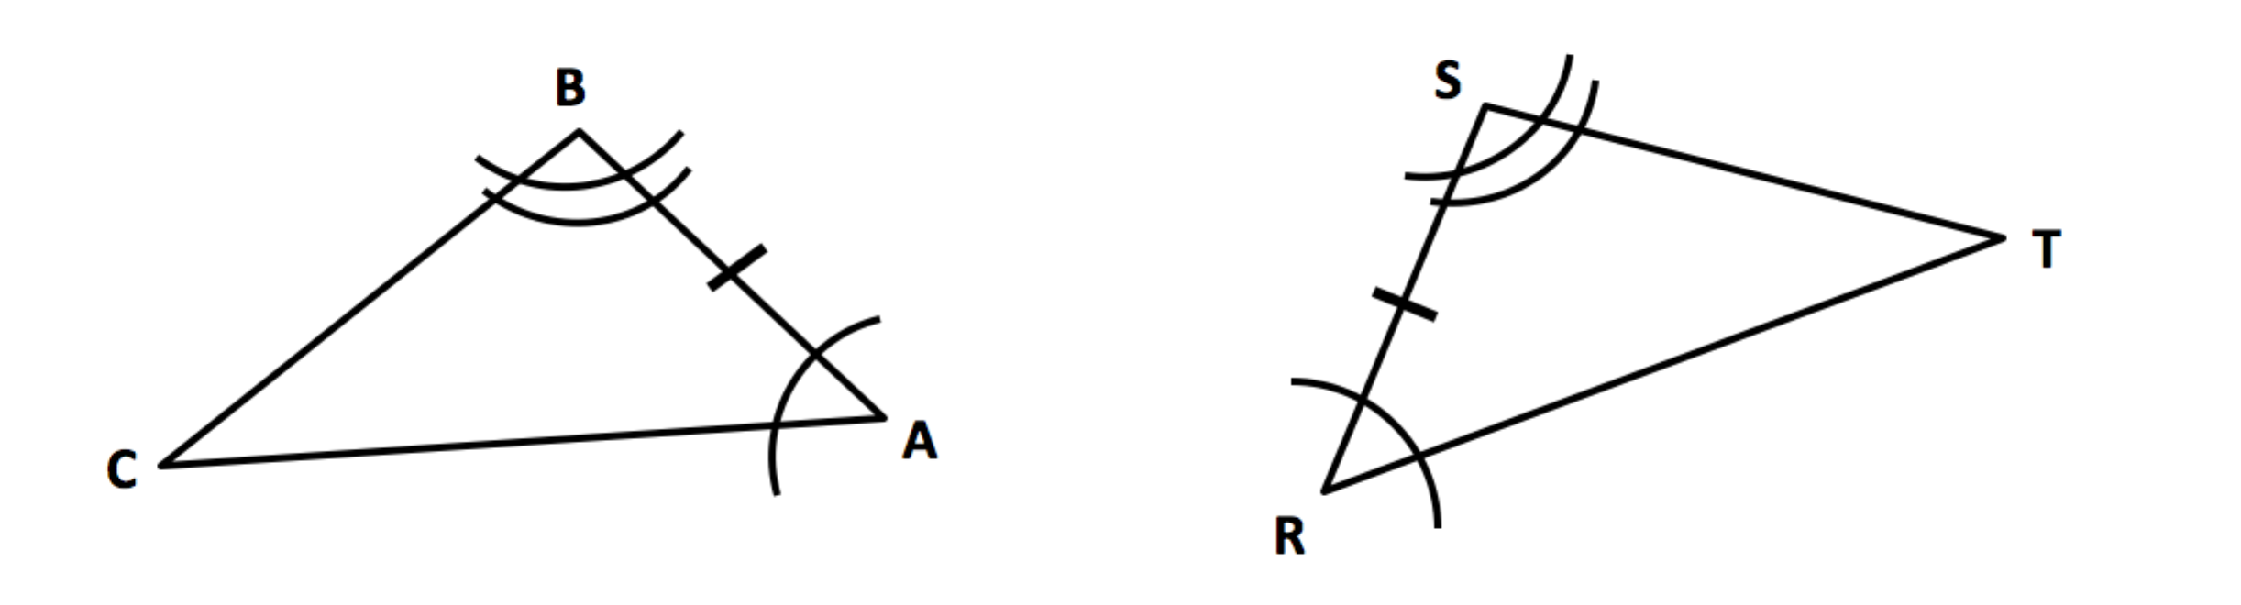

1. Based on the diagram, which angles are congruent? Which sides?
2. To convince ourselves that these two triangles are congruent, what else would we need to know?
3. Use tracing paper to find a sequence of transformations that will show whether or not these two triangles are congruent.
4. List your sequence of transformations here:

Your sequence of transformations is enough to show that these two triangles are congruent, but how can we guarantee that *all* pairs of triangles that share ASA criteria are congruent?

Perhaps your sequence of transformations looked like this:

We can use the word “coincides” when we want to say that two points or line segments occupy the same position on the plane. When making arguments using transformations we will use the word a lot.

* **translate** point *A* until it coincides with point *R*
* **rotate**  about point *R* until it coincides with 
* **reflect** Δ*ABC* across 

Now the question is, how do we know that point *C* has to land on point *T* after the reflection, making all of the sides and angles coincide?

1. *Answer this question as best you can to justify why ASA criteria guarantees two triangles are congruent. To answer this question, it may be helpful to think about how you know point C can’t land anywhere else in the plane except on top of T.*

Using tracing paper, experiment with these additional pairs of triangles. Try to determine if you can find a sequence of transformations that will show if the triangles are congruent. Be careful, there may be some that aren’t. If the triangles appear to be congruent based on your experimentation, write an argument to explain how you know that this type of criteria will always work. That is, what guarantees that the unmarked sides or angles must also coincide?

1. 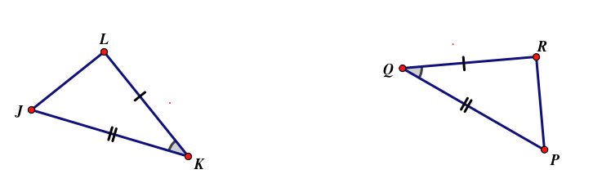Given criteria: __________ Are the triangles congruent? _________

List your transformations *If the triangles are congruent, justify why this*

in the order performed: *will always be true based on this criteria:*

1. Given information: __________ Are the triangles congruent? _________

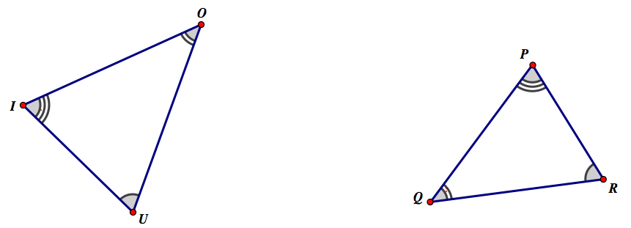

List your transformations *If the triangles are congruent, justify why this*

in the order performed: *will always be true based on this criteria:*

1. Given information: __________ Are the triangles congruent? _________

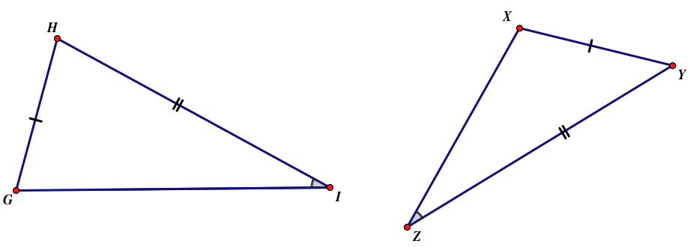

List your transformations *If the triangles are congruent, justify why this*

in the order performed: *will always be true based on this criteria:*

1. Given information: __________ Are the triangles congruent? _________

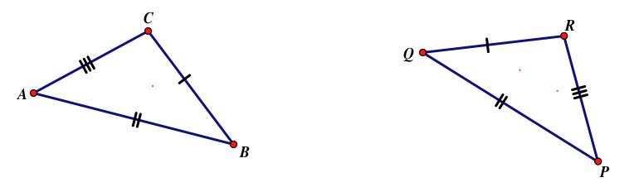

List your transformations *If the triangles are congruent, justify why this*

in the order performed: *will always be true based on this criteria:*

1. Based on these experiments and your justifications, what criteria or conditions seem to guarantee that two triangles will be congruent? List as many cases as you can. Make sure you include ASA from the triangles we worked with first.
2. Your friend wants to add AAS to your list, even though you haven’t experimented with this particular case. What do you think? Should AAS be added or not? What convinces you that you are correct?